

**Department of Electrical and Computer Engineering**

| Course Number | CPS510 |
| --- | --- |
| Course Title | Database Systems I |
| Semester/Year | F2022 |
| Instructor | Dr. S. B. Tajali |
| Lab Section | 7 |

| Assignment No. | 9 |
| --- | --- |
| Assignment Title | Assignment 9: Demonstration of application |

| Submission Date: | November 21, 2022 |
| --- | --- |
| Due Date: | November 21, 2022 |

| Student Name | Ethan Moo-Young | Ernestine Ho | Abel Abraham Thomas |
| --- | --- | --- | --- |
| Student ID | 501016708 | 501022253 | 501029194 |
| Signature |  |  |  |

Contents of [Book] Table

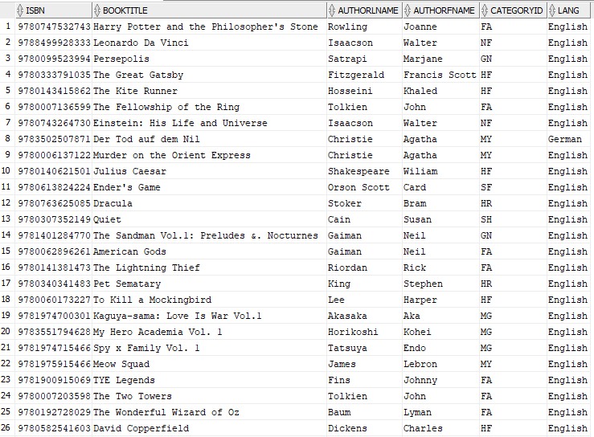



Contents of [BorrowedBooks] Table

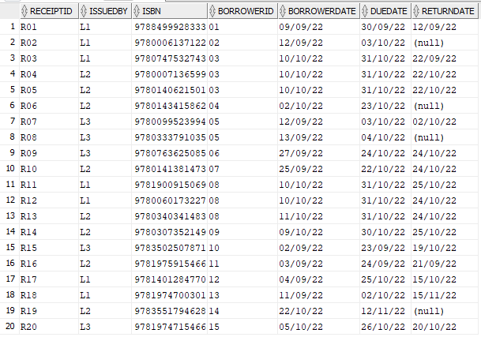

Contents of [Category] Table

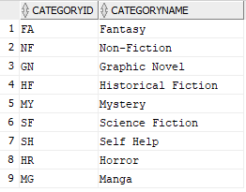

Contents of [Client] Table

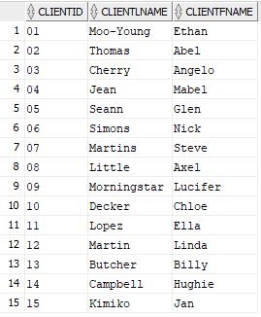

Contents of [Shelf] Table

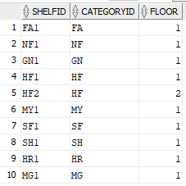

Contents of [Staff] Table

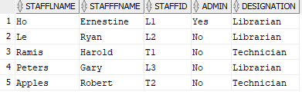

Unix Scripts



create_tables.sh

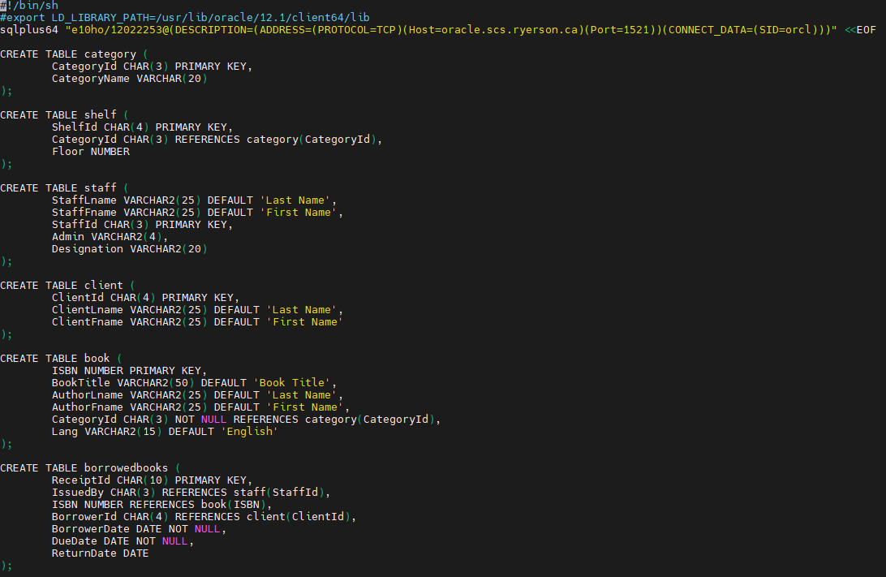

drop_tables.sh

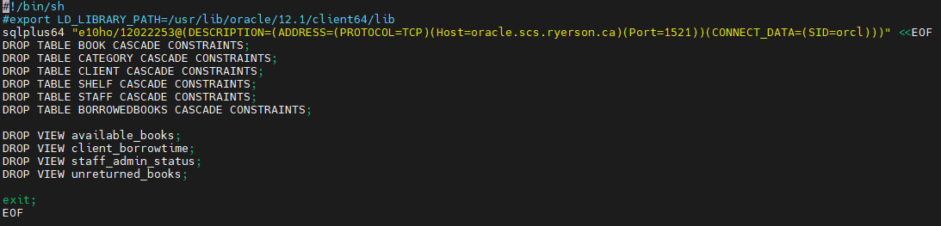

populate_tables.sh

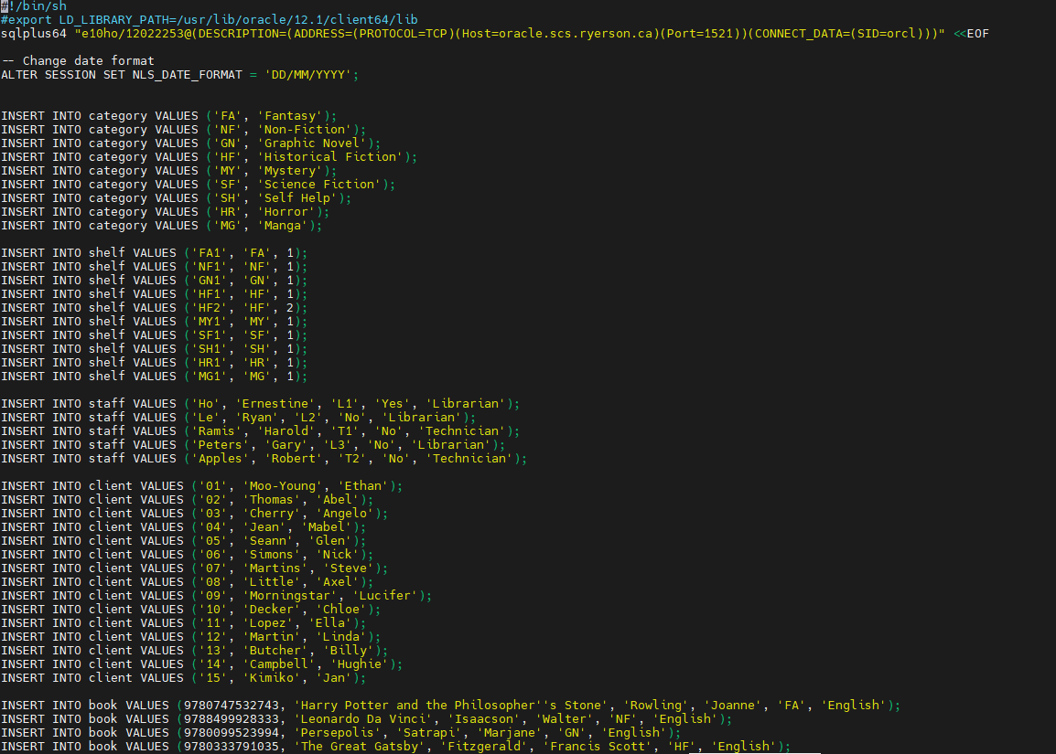

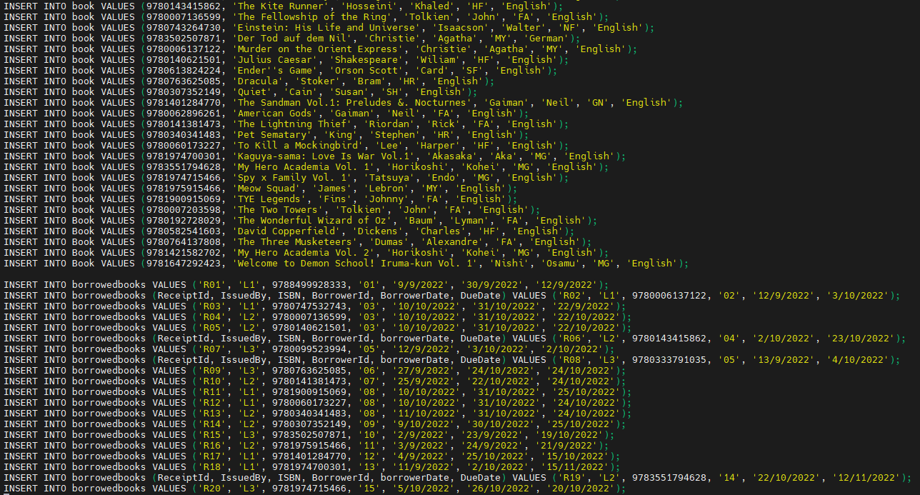

queries.sh

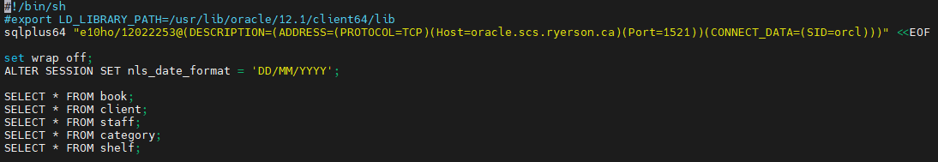

view_table.sh

